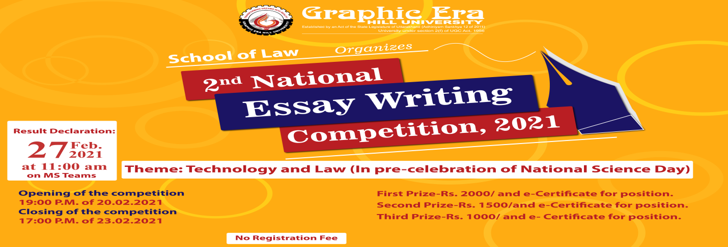
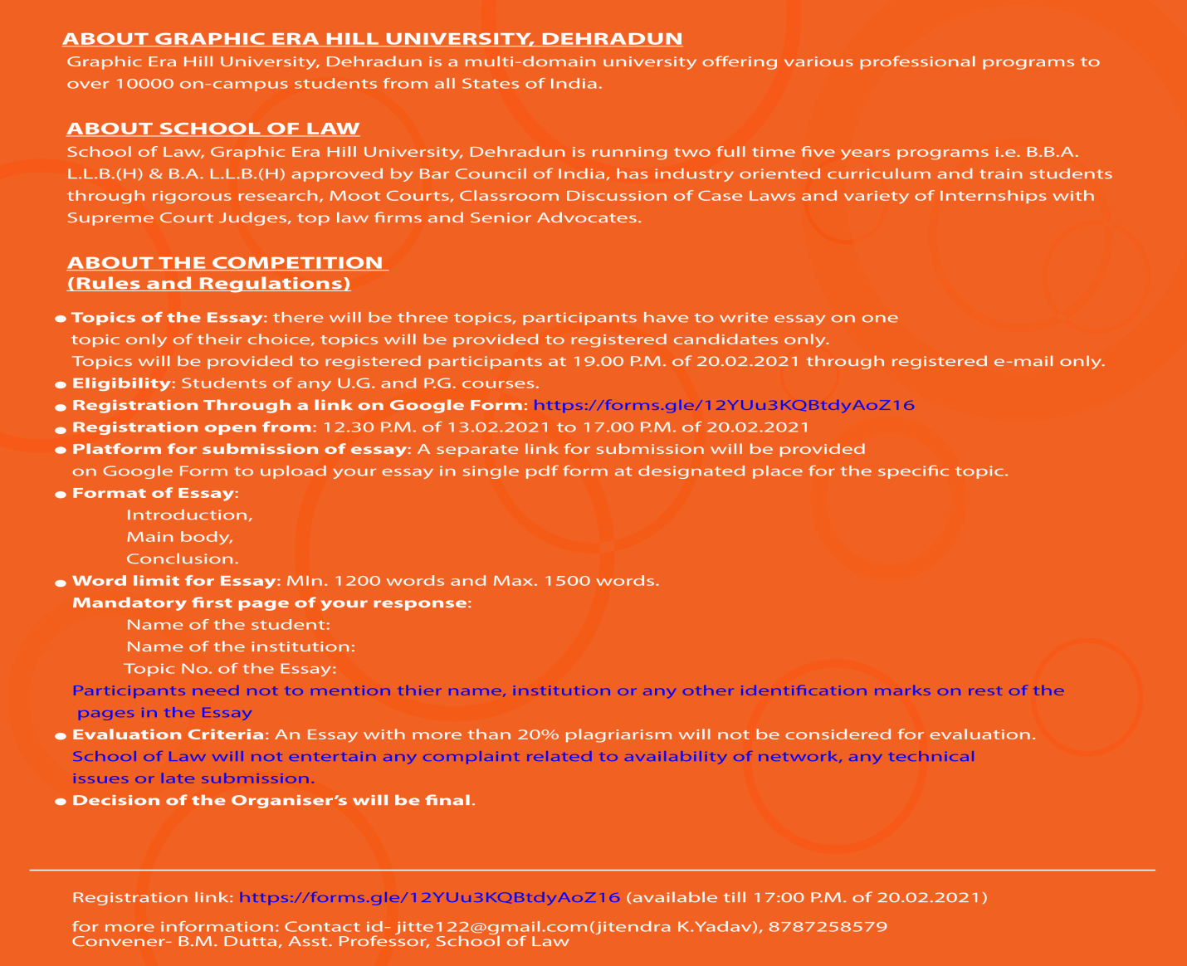
School of Law, Graphic Era Hill University is organizing 2nd National Essay Writing Competition-2021 on February 27, 2021 under the broad theme of 'Technology and Law' in pre-celebration of National Science Day . The event will target U.G and P.G. students of reputed universities and institutions of any stream from all over the country. We are expecting more than one hundred pan India participants in this prestigious competition. The results will be declared online at 11.00 a.m. on 27.02.2021. The objective of this competition is to excel the research and writing skills of the students on a particular topic for their future endeavours.
Prizes for the winners of the competition are: First Prize- Rs.2000/, Second Prize- Rs.1500/ and Third Prize- Rs.1000/ and e- certificate for all positions.
Detailed rules and regulations are given in the attached brochures.
Kindly registered through link- https://forms.gle/12YUu3KQBtdyAoZ16
Looking forward for more and more participation through registration.

