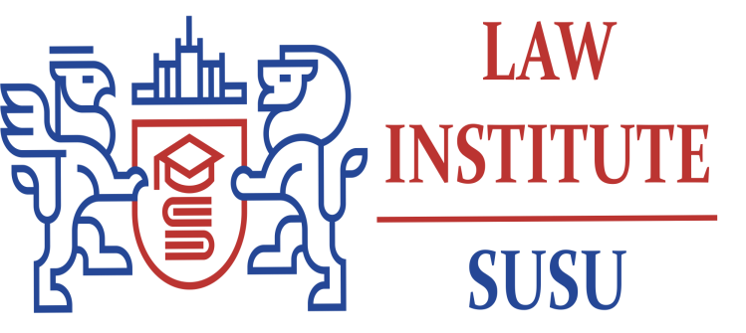
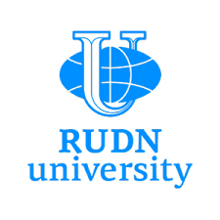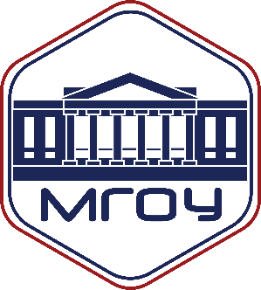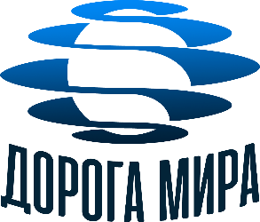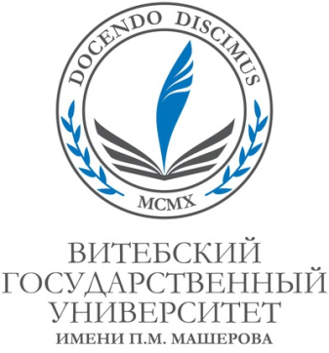

Dear Colleagues!

The Department of Jurisprudence of the Institute for Scientific Information of Social Sciences of the Russian Academy of Sciences (INNION RAS) with the support of RFBR grant № 19-011-00058
In partnership with the Institute of Law at the South Ural State University (National Research University), Department of Constitutional Law of the Institute of Law of the Peoples' Friendship University of Russia, Law Faculty of the Moscow State Regional University, P.M. Masherov Vitebsk State University, as well as with the International Foundation "The Road to Peace", the French Center for Culture and Cognition
invite you to take part in International Conference "Principles of Constitutional Law as Legal Regulators of Modern Life and Development", dedicated to the anniversary of Professor, Doctor of Law Irina Anatolievna Umnova-Konyukhova.
It is proposed to discuss the following topical issues:
- principles of constitutional law as a value in the system of legal regulation of social relations;
- principles of constitutional law and principles of international law: theory and practice of interaction
- principles of law as a global law in the 21st century;
- taxonomy as a methodology of systematization of the principles of constitutional law;
- principles of constitutional law and human rights;
- trends and prospects of development of the principles of constitutional law in the xxist century.
- principles of constitutional law in constitutional futuristic law and in constitutional futurology;
- principle of humanism vs. transhumanism as the key idea of law development in the XXI century, etc.
The conference will take place on November 19, 2021. Beginning of the conference - 11:00 a.m. Technical data for connection to the conference will be sent to the participants additionally.
To participate in the conference it is necessary to send the participant application till November 10, 2021 by e-mail: law-for-future@mail.ru
Participation in the conference is free of charge; travel and accommodation expenses are paid by the participants themselves.
A collective monograph is planned to be published by the results of the conference.
Conference participants submit their presentations by January 15, 2022. Conference organizers reserve the right to select the topics of presentations to be included in the program and the materials presented for publication.

