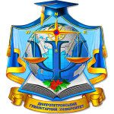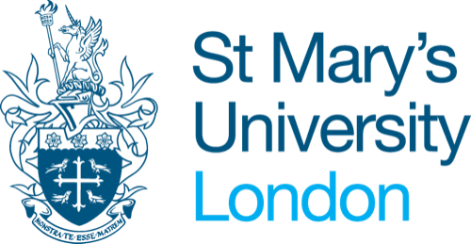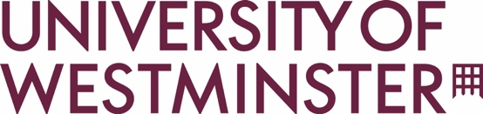

------------------------------------------------------------------
Conference: Call for Papers
LEGAL CHALLENGES OF THE GLOBALISED WORLD:
How should the law protect and realise rights?

Online Zoom conference organised by Dnipro Humanitarian University,
St. Mary’s University, and the University of Westminster
Thursday 12 October 2023
---------------------------------------------------------------

AIMS:
Covid-19 brought about a temporary pause in international and national travel, but the use of communication technology increased and transformed global networks and connections. Legal challenges accompany these transnational interactions. This conference seeks to address these global challenges and generate an international discussion. For instance, how should the law approach globalisation? What legal issues arise from globalisation? What should global legal regulation look like in 2030, 2040 and beyond? How should global law be framed?

TOPICS:
This conference welcomes papers on, but not limited to:
- Philosophical, jurisprudential, theoretical and historical aspects of law’s evolution
- Issues of regulating public social relationships under conditions of globalisation
- Legal challenges of traditional and novel private relationships
- Legal rights realization and protection within judicial and non-judicial procedures
- International and national experience of countering crime
- International aspects of legal rights realization and protection
- Legal education under conditions of globalization

ABSTRACT SUBMISSION:
Please submit a 200-250 word abstract with a 200 word biography, by 12 noon on Monday 24 July 2023, to:
- Judith Bourne: judith.bourne@stmarys.ac.uk and
- Avis Whyte: whytea@westminster.ac.uk

We welcome papers from academics at all stages of their careers, lawyers and independent researchers.

