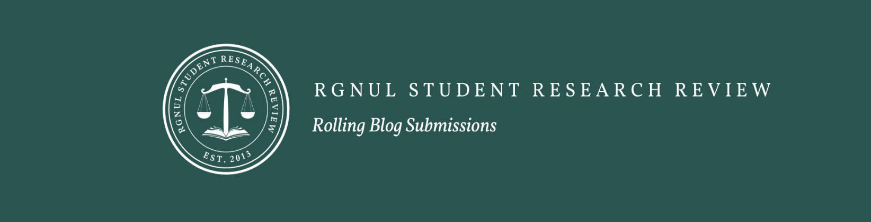

About RGNUL Student Research Review

The RGNUL Student Research Review (RSRR) is the flagship student-run, double-blind peer-reviewed journal of the Rajiv Gandhi National University of Law, Punjab. Established in 2013,
RSRR has been driven by the goal of publishing critical and interdisciplinary scholarship authored by law students, academics, and professionals on a broad range of issues on law and the social sciences. Through its journal and online blog, RSRR continues to contribute meaningfully to academic and policy-oriented discourse in India and beyond.

Blog Submissions​
​The RSRR Rolling Blog provides a platform for discussing timely legal issues. To submit a piece for consideration, please fill out the submission form here. Submissions should be around 1,500 to 2,000 words. In certain circumstances where the topic requires a more comprehensive analysis, longer submissions may be considered. Please avoid footnotes unless absolutely necessary; use hyperlinks to cite sources instead. In the event your submission requires changes, we reserve the right to request a revised version before publication. Owing to our academic schedule, submissions for the Rolling Blog are closed during June-July and December-January.

